|  |  |  |  |  |  |
| --- | --- | --- | --- | --- | --- |
| Test scenario | Test case | Test Data | Except Results | Actual Result | Pass/Fail |
| Calculate premium | Customer aged less than 25 who own a class A – C  Mileage: 10000 | See Pictures 1 bellow | Annual premium £2000 and monthly premium of £166.67 | Annual premium £2000 and monthly premium of £166.67 | Pass |
|  | Customer aged less than 25 who own a class D – E  Mileage: 10000 | See Pictures 2 below | 80% of the full rate is £1800 and monthly premium is £150 | 80% of the full rate is £1800 and monthly premium is £150 | Pass |
|  |  |  |  |  |  |
|  |  |  |  |  |  |
|  |  |  |  |  |  |
|  |  |  |  |  |  |
|  |  |  |  |  |  |
|  |  |  |  |  |  |
|  |  |  |  |  |  |
|  |  |  |  |  |  |
|  |  |  |  |  |  |
|  |  |  |  |  |  |
|  |  |  |  |  |  |

Pictures 1

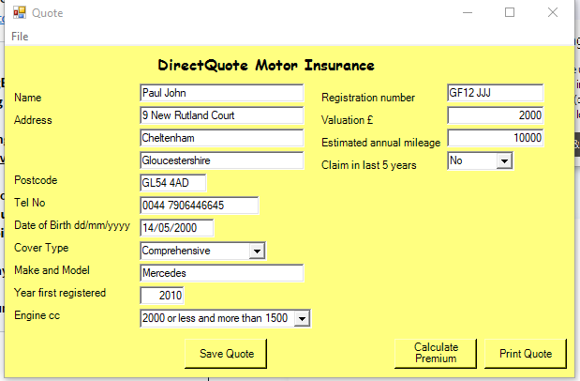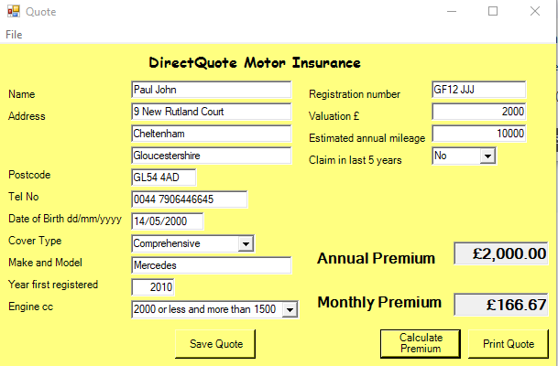

Input premium Output premium

Pictures 2

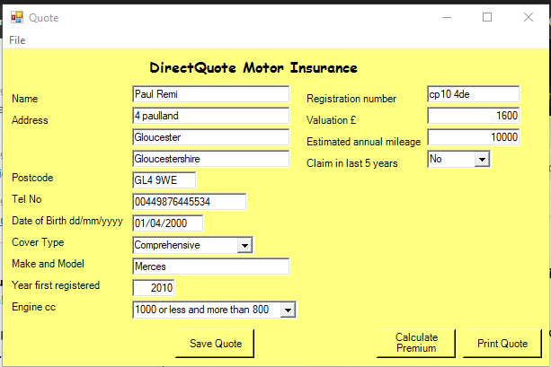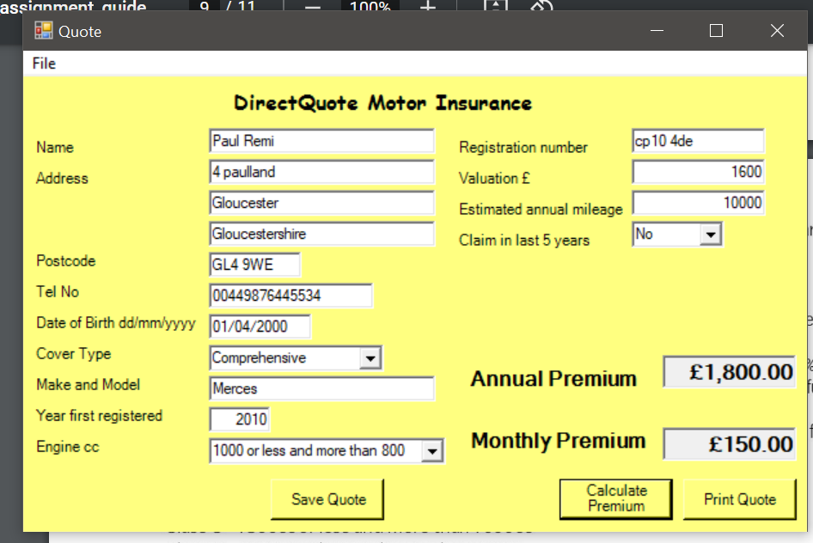

Input premium Output premium